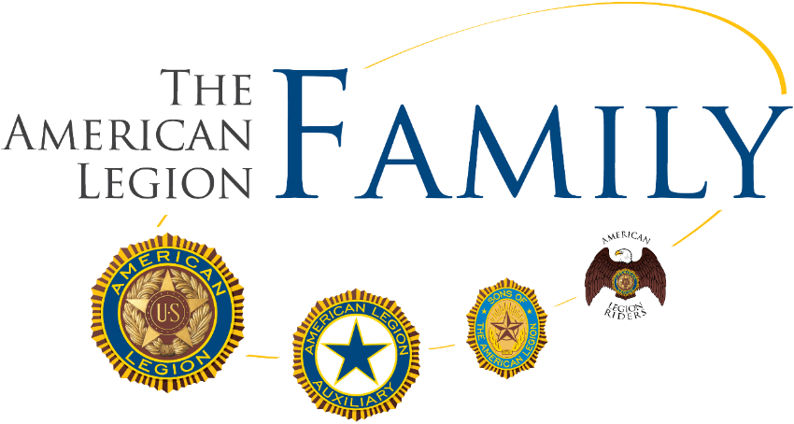
 |  | Ellsworth Editorial | October 2025
 |  | The latest news, views, and announcements
INSIDE  __  Commanders Corner  A message from Post Commander Craig Barnes  __  Notes from the Auxiliary  A message from President Becky Overland  __  American Legion Riders  A message from ALR Director Bryan Rudd |  | Duane Ellsworth Post 129  Queen Creek, AZ
Sons of The American Legion  A message from SAL Commander Vince Davis  Post 129’s Off-Roaders  A message from Director Louis Clark |  | Commanders Corner  Changes to the Website & Email  We have made some exciting upgrades to our website. We have added a few pages and made others easier to find. Check it out at www.queencreeklegion.com.  We have also made some changes to our email system. We will not be sending out long emails in the near future and will rely on our members to check the website for events and information. This monthly newsletter will also be a source of information.  We are still leading District 4 in membership, with 96.45% of our goal achieved. We need 11 members to renew to reach 100%, and 36 to meet the state's goal of 103%.  Currently, we have 310 active members and 75 inactive members. By renewing, you are helping us fund our Queen Creek veteran’s assistance and youth programs, and you are raising money for a future post home. We need you

The Review
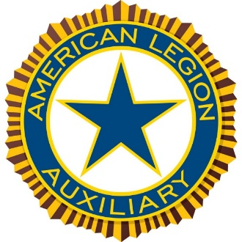  Notes from the Auxiliary  - Let me introduce you to Unit 129 American Legion Auxiliary. Unit 129 has over 33 members at last count, including one Jr. member and two girls who have just turned 18 and are now considered adult members. If you are a Legion member and have a spouse, sister, mother, grandmother, or direct/adopted female descendant, we would love to talk to them. Members are also eligible to join if their father or spouse served in either of the following periods: April 6, 1917, to November 11, 1918, and any time after December 7, 1941. We are always recruiting! Our Membership committee includes Dawn Oliphant and Jennifer Revolt. One of our service projects in the past two years has been to identify veterans living in Queen Creek assisted living facilities, adult family homes, and the Amberlin Retirement Community. The American Legion and Legion Riders have joined us as we honor each veteran with a fleece blanket embroidered with their branch of service, a gift bag, and a Thank You card. The Legion presents a certificate of appreciation to each veteran, and the Legion Riders present a Challenge Coin and honor the veterans with an honorary ride-by. We contact each facility every three months to identify new residents we can honor. As of February 20, 2026, we interviewed and chose two girls from Queen Creek High School to attend AZ Girls State May 30-June 6, 2026. Our delegates are Audrey Bradshaw and Kaydence Valentine. We are confident that both Audrey and Kaydence will represent Queen Creek in special ways. |  |  | Sons of The American Legion Update    Vince Davis, Jeff Brown, and Rick Noem have stood up and are committed to reviving our Squadron 129!  We definitely still need support, so if you would consider being Adjutant or Vice Commander, please let any of us know. Vince can be reached at commandersalqc129@gmail.com and at 480 720 4040.  Our next meeting will be March 21, 2026 at 8a, early enough for you to make the meeting and still volunteer at Roots and Boots. We are updating our By Laws and launching a business support group, so it should be interesting.  Now is the time to step up. Your participation and leadership will help keep our Squadron active, thriving, and able to support the mission of Post 129.
 | The American Legion Riders  The Riders of Post 129 are very active in supporting our community through service. One of their ongoing projects is helping prepare food boxes for the United Food Bank in Mesa.  The next volunteer event will be held on Saturday, March 7th. Slots are limited and usually fill quickly with Riders.  If you would like to participate, please contact Riders Director Bryan Rudd at Rudd.bryan@gmail.com. Bryan can also connect you with the Food Bank staff to help arrange an alternative volunteer time if this date doesn’t work for you.  The Riders are always welcoming new participants. Whether to join the Riders or just tag along on a ride. Reach out to Bryan for more information.


Post 129’s Off-Roaders
We still have two slots available for SXS cars at the Queen Creek Christmas parade on June 6. We will be at the front of the parade, which is nice.
The Queen Creek SXS parade is on the evening of June 13. This is a massive event with over a thousand vehicles participating last year. Veterans are up front at the start of the parade, which is nice.
With the cooler weather, we will start our riding season. We plan to kick off the event with a Four Peaks ride. This ride will take us over the mountain to Lake Roosevelt. We will have lunch there and return. This ride will take about five hours. I have not set a date yet. To get the most involved, I would appreciate hearing from you about which Saturday works best for you. Also, if you have extra seats for fellow veterans, let me know.
Here are pics from a ride last year.
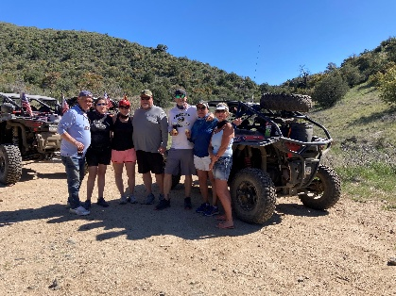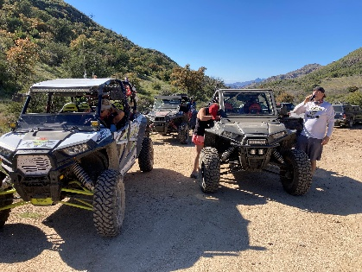
Happy Trails!

Standing Monthly Events
Every Monday, 5:00 to 7:00 pm Queen of Hearts progressive Raffle @ TC’s Pub & Grub
1st Saturday, IHOP. Join us at 8:00 am for the family breakfast, bring your family, and if you know another Veteran, invite them and their family.
1st Saturday, Riders Meeting (Contact Riders for location)
2nd Thursday, Barro’s Pizza. Join us at 11:30 am for a family lunch, bring your family, and if you know another Veteran, invite them and their family.
3rd Saturday, Post 129 Office
8:00 am American Legion Auxiliary meeting
8:00 am Sons of the American Legion meeting
9:00 am Breakfast (Donations Welcome)
10:00 The American Legion Post #129 Meeting
E-Board meeting to follow

Post 129’s Family Events
March
Mar 7th Sat 9:00 am to 3:00 pm, Cornhole Tournament & Spring Market @ Canyon State Academy
Mar 14^{th,} Sat Area “A” Oratorical Finals Post 36 Tucson
Mar 17-22nd Wed – Sun Roots N’ Boots @ Queen Creek Equestrian Center
Mar 28th Sat 8:00 am – Noon AZ State Oratorical @ Arrowhead Resort Apts.
April
Apr 29th Wed 10:00 am Queen Creek High School JROTC Awards @ Queen Creek Performing Arts building
Apr 29th Wed 5:00 pm Eastmark High School JROTC awards @ Eastmark High School
May
May 16th Sat 11:00 am Armed Services Day @ Pecan Lake Entertainment
May 25th Mon 10:00 am Memorial Day @ San Tan Memorial Gardens
***Please see each of our pages for contact information and meeting times***

