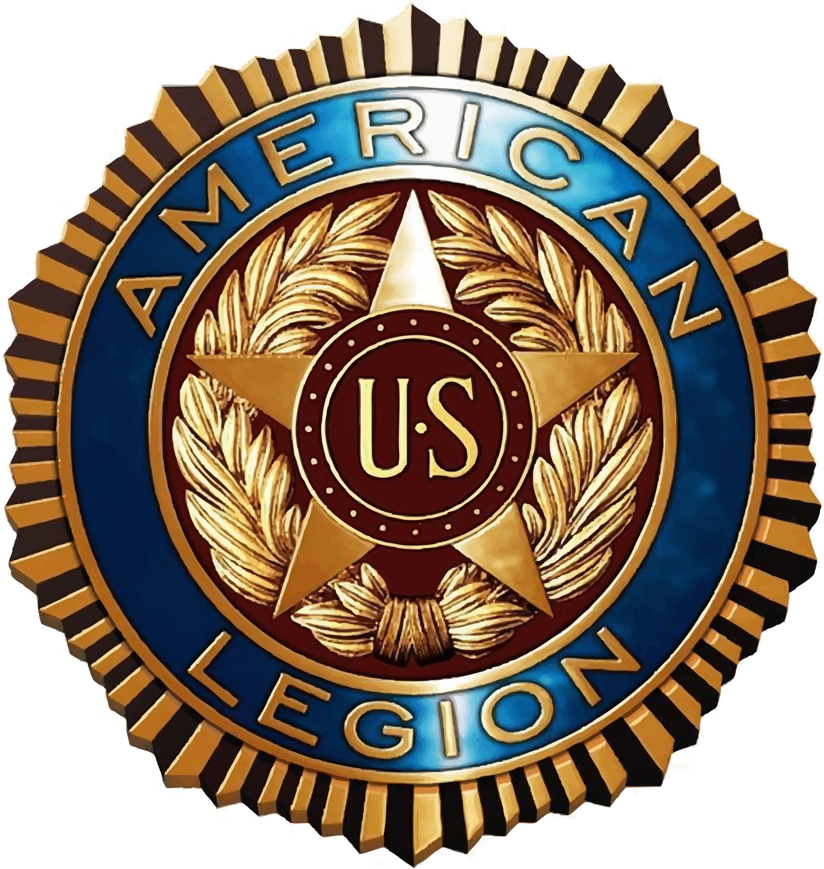
Duane Ellsworth Post 129 Officer Nominations
(Current officers in red) (Black – Not going to run)
Commander (Craig Barnes)
____________________________________________ ____________________________________________
____________________________________________ ___________________________________________
Vice Commander (Vacant)
____________________________________________ ____________________________________________
____________________________________________ ____________________________________________
2nd Vice Commander (Shawn Sunnarborg)
____________________________________________ ____________________________________________
____________________________________________ ____________________________________________
Finance Officer (Robert Keller)
____________________________________________ ____________________________________________
____________________________________________ ____________________________________________
Sgt-at-Arms (Huxley Madeheim)
____________________________________________ ____________________________________________
____________________________________________ ____________________________________________
Members at Large
(Don Ayers, Louis Clark, Bruce Fraser, Charles Ridgeway, Scott Sossaman, Dennis Walker)
____________________________________________ ____________________________________________
____________________________________________ ____________________________________________
____________________________________________ ____________________________________________
____________________________________________ ____________________________________________
____________________________________________ ____________________________________________
Election Year: 2026–2027

